Blog
Our laser engraver software EcubMakerLaser has been updated to English.

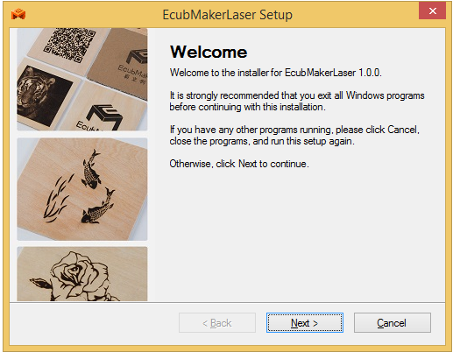
Our software can not only support a variety of image formats, but also adjust the image according to your needs.

More importantly, it is also equipped with detailed instructions and reference values, making it easier for novices to get started.
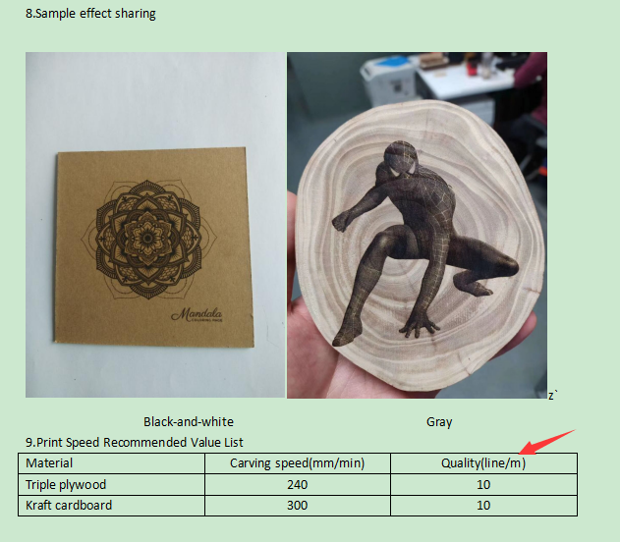

What are you waiting for? Come visit our store now.

